Sherman “Rhino”
26
MILITARY
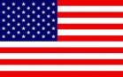
1st US 3rd US
AIR POWER
+1 1st US; +1 3rd US
RESOURCES
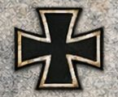
Gain 1

ORDERS: 2 Actions
+1 Attack Strength 1st US ARMY
Reduce defensive value of Bocage spaces to 1
A Rhino tank was the US nickname for Allied tanks fitted with hedgerow-breaching "tusks. By cutting apart the three-beam, tetrahedral steel anti-tank obstacles, that had been placed by the Germans by the uncounted thousands on the Normandy beaches before the landing, the Americans recycled the obstacles' steel beams into many-pronged, sharp, tusk-like assemblies to attach to the front of their M4 Sherman medium and M5 Stuart light tanks. This method of cutting through hedgerows was extremely effective in the bocage terrain of the area, where hedges were a serious obstacle for tanks.

